**Lab 3: Entity Relationship Diagram**

**Draw an entity relationship diagram then transform it to relation data model for each of the following situation. When you draw the ERD, add the attributes that you think necessary for each entity in the model.**

**Exercise 1:** Create an E-R model for the following requirements.

* An INVOICE is written by a SALESREP. Each sales representative can write many invoices, but each invoice is written by a single sales representative.
* The INVOICE is written for a single CUSTOMER. However, each customer may have many invoices.
* An INVOICE may include many detail lines (LINE) which describe the products bought by the customer.
* The product information is stored in a PRODUCT entity.
* The product's vendor information is found in a VENDOR entity.

You are required to create a conceptual data model of the data requirements for a company that

specializes in IT training. The Company has 30 instructors and can handle up to 100 trainees per training

session. The Company o;ers <ve advanced technology courses, each of which is taught by a teaching

team of two or more instructors. Each instructor is assigned to a maximum of two teaching teams or

may be assigned to do research. Each trainee undertakes one advanced technology course per training

session.

(a) Idenfy the main enty types for the company.

(b) Idenfy the main relaonship types and specify the mulplicity for each relaonship. State any

assumpons you make about the data.

(c) Using your answers for (a) and (b), draw a single ER diagram to represent the data requirements

for the company

You are required to create a conceptual data model of the data requirements for a company that

specializes in IT training. The Company has 30 instructors and can handle up to 100 trainees per training

session. The Company o;ers <ve advanced technology courses, each of which is taught by a teaching

team of two or more instructors. Each instructor is assigned to a maximum of two teaching teams or

may be assigned to do research. Each trainee undertakes one advanced technology course per training

session.

(a) Idenfy the main enty types for the company.

(b) Idenfy the main relaonship types and specify the mulplicity for each relaonship. State any

assumpons you make about the data.

(c) Using your answers for (a) and (b), draw a single ER diagram to represent the data requirements

for the company

You are required to create a conceptual data model of the data requirements for a company that

specializes in IT training. The Company has 30 instructors and can handle up to 100 trainees per training

session. The Company o;ers <ve advanced technology courses, each of which is taught by a teaching

team of two or more instructors. Each instructor is assigned to a maximum of two teaching teams or

may be assigned to do research. Each trainee undertakes one advanced technology course per training

session.

(a) Idenfy the main enty types for the company.

(b) Idenfy the main relaonship types and specify the mulplicity for each relaonship. State any

assumpons you make about the data.

(c) Using your answers for (a) and (b), draw a single ER diagram to represent the data requirements

for the company

You are required to create a conceptual data model of the data requirements for a company that

specializes in IT training. The Company has 30 instructors and can handle up to 100 trainees per training

session. The Company o;ers <ve advanced technology courses, each of which is taught by a teaching

team of two or more instructors. Each instructor is assigned to a maximum of two teaching teams or

may be assigned to do research. Each trainee undertakes one advanced technology course per training

session.

(a) Idenfy the main enty types for the company.

(b) Idenfy the main relaonship types and specify the mulplicity for each relaonship. State any

assumpons you make about the data.

(c) Using your answers for (a) and (b), draw a single ER diagram to represent the data requirements

for the company

You are required to create a conceptual data model of the data requirements for a company that

specializes in IT training. The Company has 30 instructors and can handle up to 100 trainees per training

session. The Company o;ers <ve advanced technology courses, each of which is taught by a teaching

team of two or more instructors. Each instructor is assigned to a maximum of two teaching teams or

may be assigned to do research. Each trainee undertakes one advanced technology course per training

session.

(a) Idenfy the main enty types for the company.

(b) Idenfy the main relaonship types and specify the mulplicity for each relaonship. State any

assumpons you make about the data.

(c) Using your answers for (a) and (b), draw a single ER diagram to represent the data requirements

for the company

**Exercise 2:** You are required to create a conceptual data model of the data requirements for a company that specializes in IT training. The Company has 30 instructors and can handle up to 100 trainees per training session. The Company offers five advanced technology courses, each of which is taught by a teaching team of two or more instructors. Each instructor is assigned to a maximum of two teaching teams or may be assigned to do research. Each trainee undertakes one advanced technology course per training session.

**Exercise 3:** 300 employees of a company are organized into different departments. For each employee, we have his social security number, name, address, sex, birthdate, phone and email. Each department has a name, a role and a head (who is also an employee). Note that each employee works for only one department at a time but he could change from one department to another department. Each time he works for a department, the company signs a contract specifying his salary, start date and end date. Each department handle a number of projects (each project is handled by only one department). Each project has a name, start date, end date, a project manager and a number of employees who work on it. Note that an employee could work on different projects with a specified number of hour. Each employee may have a number of dependents. For each dependent, we keep track of their name, sex, birthdate and relationship to the employee.

SOLUTION

**Exercise 1:**

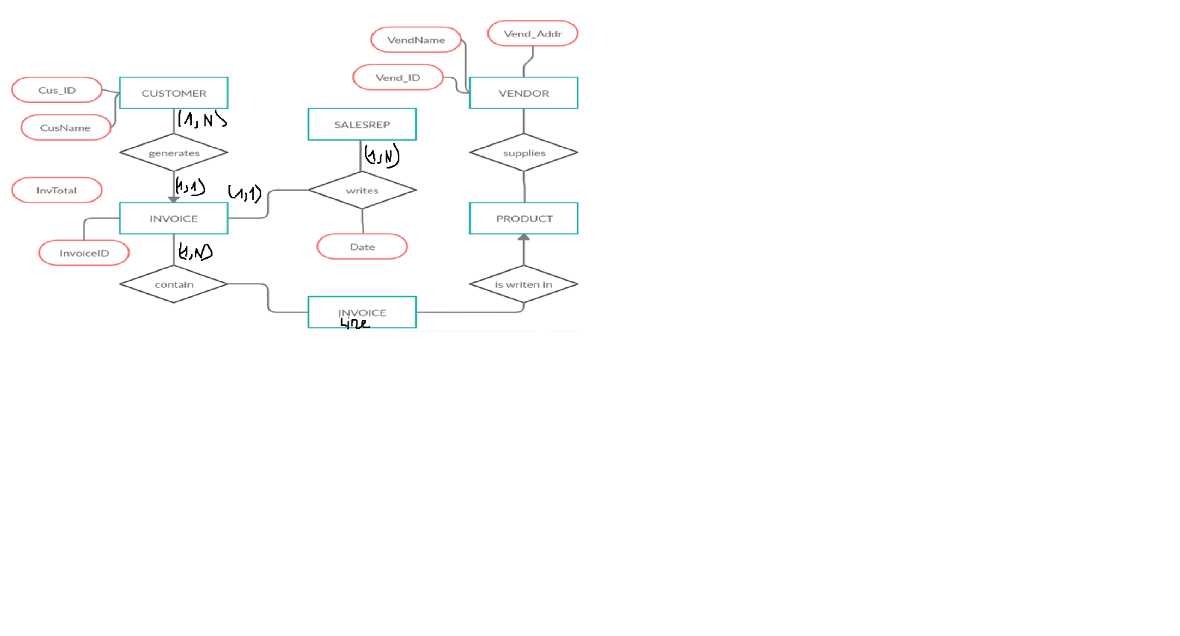

Exercise 2:

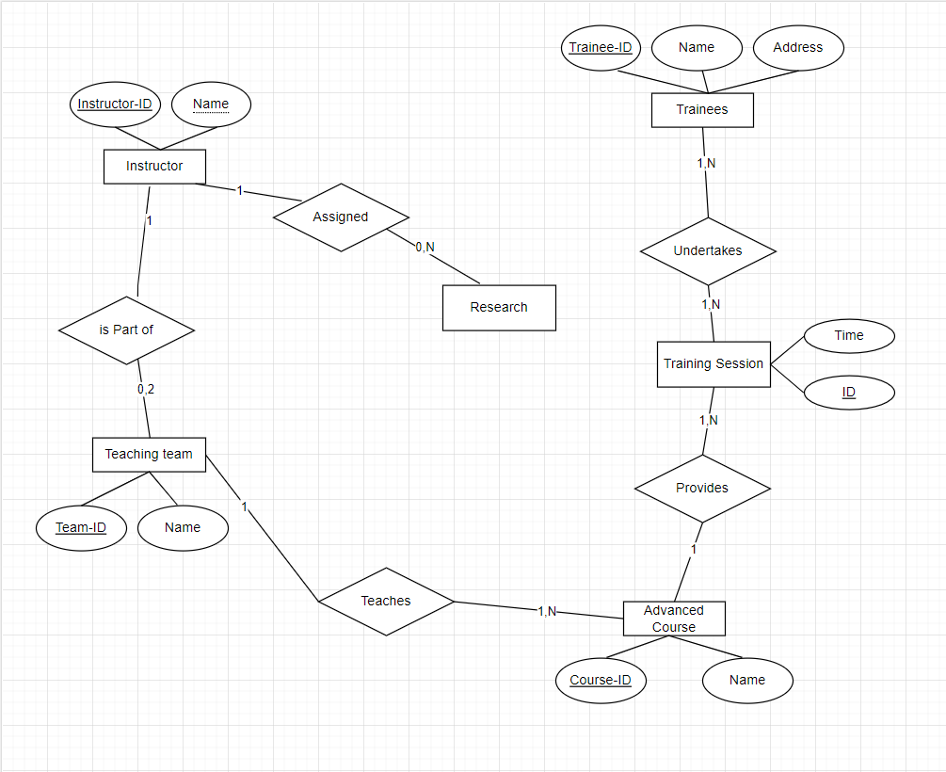

1. Idenfy the main enty types for the company.
2. (b) Idenfy the main relaonship types and specify the mulplicity for each relaonship. State any
3. assumpons you make about the data.
4. (c) Using your answers for (a) and (b), draw a single ER diagram to represent the data requirements
5. for the company.

Exercise 3:

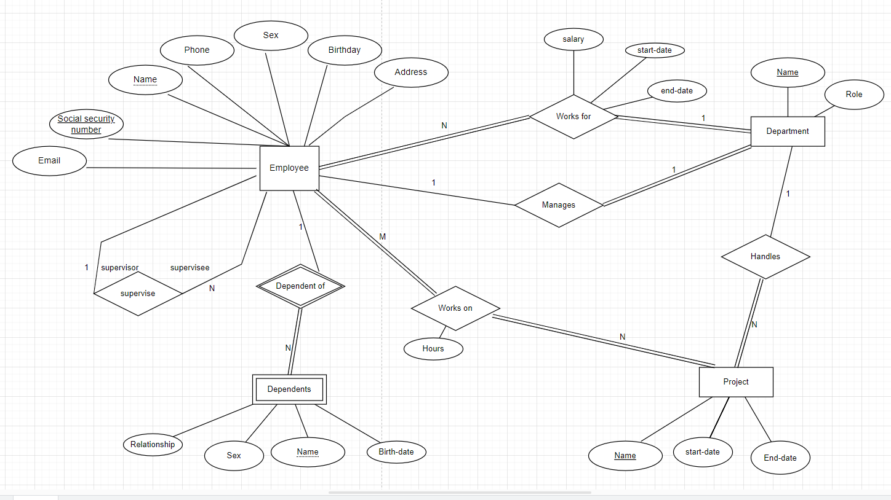

Exercise 3:

Employee(SSN ,Name ,address,sex)

Dependent(Name,phone,sex)

Contract(Num,date,salary)

Project(Name,date)

Department(d.Name,role.head)

Exercise 3:

Employee(SSN ,Name ,address,sex)

Dependent(Name,phone,sex)

Contract(Num,date,salary)

Project(Name,date)

Department(d.Name,role.head)

Exercise 3:

Employee(SSN ,Name ,address,sex)

Dependent(Name,phone,sex)

Contract(Num,date,salary)

Project(Name,date)

Department(d.Name,role.head)

Exercise 3:

Employee(SSN ,Name ,address,sex)

Dependent(Name,phone,sex)

Contract(Num,date,salary)

Project(Name,date)

Department(d.Name,role.head)